SIMATS ENGINEERING
ASSESSMENT TOOL 1: Algorithm Design Challenge
COURSE NAME: | ARTIFICIAL INTELLIGENCE AND EXPERT SYSTEMS | COURSE CODE: | MLA01

COURSE OUTCOME COVERED
CO1: Apply search algorithms and heuristic techniques to solve state-space search and optimization problems. (BTL 3)
Assessment Tool Weightage: 40 %
Total Marks: 100 Time: 90 Mins
No. of Questions: 5
Annexure A
Algorithm Design Challenge

Code of Conduct:

I MOKSHITHA KILARI(192525413) (Name / Reg No) certify that this submission is my original work and that I have adhered to the guidelines specified for this assessment.
I understand that any violation of academic integrity rules will result in disciplinary action.

Signature of the student: MOKSHITHAKILARI

Criterion | Weightage | Marks Obtained
Problem Analysis and Understanding | 15%
AI Algorithm Selection & Justification | 15%
Algorithm Design / Pseudocode | 25%
Application of AI Concepts (Greedy, A*, CSP, Minimax, etc.) | 15%
Diagram / State Space / Search Tree Representation | 10%
Complexity Analysis and Solution Efficiency | 10%
Originality, Critical Thinking, and Presentation | 10%
Total | 100%

Signature of the Faculty Total Marks Awarded
Answer all the Questions

Q.No | Question | Topics
1 | Design an algorithm using Greedy Best-First Search to find a path from a source node to a goal node for the given graph. Clearly define the heuristic function, show the node expansion order, and justify why Greedy Best-First Search is suitable for this problem. | Informed Search, Greedy Best-First Search, Heuristic Functions
2 | A delivery robot must travel from a warehouse to a customer through a weighted road network. Design an A Search algorithm to determine the optimal path. Calculate g(n), h(n), and f(n) for each expanded node, and explain why A guarantees the optimal solution. | A* Search, Heuristic Functions
3 | A university needs to prepare an examination timetable without scheduling conflicting subjects at the same time. Design the problem as a Constraint Satisfaction Problem (CSP) by identifying variables, domains, and constraints. Explain how MRV and Forward Checking improve the efficiency of the solution. | CSP, MRV, Forward Checking
4 | Design the Minimax algorithm for the given game tree to determine the best move for the MAX player. Then apply Alpha–Beta Pruning to the same tree and indicate which nodes are pruned. Compare the number of nodes evaluated before and after pruning. | Game Playing, Minimax, Alpha–Beta Pruning
5 | A warehouse robot operates in a dynamic environment where obstacles may appear unexpectedly. Design an intelligent search strategy using either Local Search or an Online Search Agent. Explain how the algorithm adapts to environmental changes and compare its performance with informed search algorithms. | Local Search, Optimization, Online Search Agents

Structure of the Answer – Algorithm Design Challenge

S.No | Sections | Expected Content
1 | Problem Statement | Briefly describe the given problem in your own words.
2 | Problem Analysis | Identify the initial state, goal state, assumptions, and constraints.
3 | AI Technique Selection | Specify the most appropriate AI algorithm/search technique (e.g., Greedy Best-First Search, A*, CSP, Minimax, Local Search).
4 | Justification of Algorithm | Explain why the selected algorithm is suitable compared to other search techniques.
5 | State Space Representation | Represent the problem using a state-space diagram, search graph, game tree, or constraint graph, as applicable.
6 | Variables, Domains, and Constraints (Applicable for CSP problems) | Identify variables, possible domains, and constraints. If not applicable, mention "Not Applicable".
7 | Heuristic Function (Applicable for Informed Search) | Define the heuristic function h(n) and explain whether it is admissible or appropriate for the problem. If not applicable, mention "Not Applicable".
8 | Algorithm Design / Pseudocode | Write the step-by-step algorithm or pseudocode for solving the problem.
9 | Flowchart / Algorithm Diagram | Draw a flowchart, search tree, game tree, or algorithm workflow illustrating the solution.
10 | Working / Execution Trace | Demonstrate the execution of the algorithm with at least one example, showing intermediate steps such as node expansion, constraint propagation, or game-tree evaluation.
11 | Complexity Analysis | Analyze the Time Complexity and Space Complexity of the proposed algorithm.
12 | Advantages and Limitations | Discuss the strengths and limitations of the selected algorithm for the given problem.
13 | Conclusion | Summarize the effectiveness of the designed algorithm and suggest possible improvements or alternative approaches.

Question 1 — Greedy Best-First Search
Design an algorithm using Greedy Best-First Search to find a path from a source node to a goal node for the given graph. Define the heuristic function, show the node expansion order, and justify why Greedy Best-First Search is suitable.

1. Problem Statement
Given a weighted, undirected graph of locations connected by roads, we must find a path from a source node S to a goal node G using Greedy Best-First Search (GBFS) — an informed search technique guided purely by a heuristic estimate of closeness to the goal.

2. Problem Analysis
- Initial state: agent located at source node S.
- Goal state: agent located at goal node G.
- Assumptions: the graph is fully known in advance; a heuristic h(n) estimating distance from any node n to G is available for every node.
- Constraints: each node is expanded at most once (a visited set prevents cycles); search terminates when G is expanded or the frontier is empty.

3. AI Technique Selection
Greedy Best-First Search (Informed / Heuristic Search).

4. Justification of Algorithm
GBFS is ideal when a good heuristic exists and a fast (not necessarily optimal) route is acceptable — e.g. quick navigation suggestions. Unlike uninformed search (BFS/DFS/UCS), which ignores goal direction, GBFS always expands the node that looks closest to the goal via h(n), so it typically explores far fewer nodes than uninformed strategies. It is preferred over A* here when speed matters more than a strict optimality guarantee, and it is not comparable to CSP/Minimax, which solve different problem types (assignment / adversarial games) rather than single-agent pathfinding.
5. State Space Representation
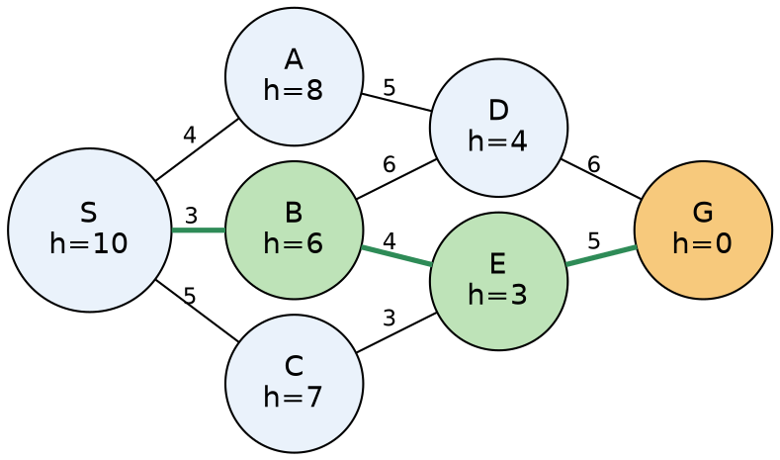

6. Variables, Domains, and Constraints (CSP)
Not Applicable — this is a path-search problem, not a constraint-assignment problem.

7. Heuristic Function
h(n) = estimated straight-line distance from node n to goal G:
h(S)=10 h(A)=8 h(B)=6 h(C)=7
h(D)=4 h(E)=3 h(G)=0
GBFS does not require h(n) to be admissible for it to run (admissibility only matters for A*'s optimality guarantee); here h is a reasonable straight-line estimate towards G.

8. Algorithm Design / Pseudocode

GREEDY-BEST-FIRST-SEARCH(S, G):
frontier <- PriorityQueue ordered by h(n); insert S
explored <- { }
while frontier is not empty:
n <- frontier.pop() // smallest h(n)
if n == G: return reconstruct_path(n)
add n to explored
for each neighbour m of n:
if m not in explored and m not in frontier:
insert m into frontier with priority h(m)
parent(m) <- n
return FAILURE

9. Flowchart / Algorithm Diagram
The state-space graph in Fig. 1 doubles as the search-tree/flow diagram: at every expansion the algorithm branches to all neighbours and immediately discards all but the lowest-h(n) branch, following the highlighted green path.

10. Working / Execution Trace
Step | Node Expanded | h(n) | Frontier after expansion (node:h)
1 | S | 10 | A:8, B:6, C:7
2 | B (min h) | 6 | A:8, C:7, D:4, E:3
3 | E (min h) | 3 | A:8, C:7, D:4, G:0
4 | G (min h) | 0 | Goal reached — stop

Path found: S → B → E → G (path cost = 3 + 4 + 5 = 12). Note that GBFS only guarantees a heuristically-guided path, not the minimum-cost one.

11. Complexity Analysis
Time complexity: O(b^m) in the worst case (b = branching factor, m = maximum depth of the search tree) — a poor heuristic can cause exploration close to the entire graph. Space complexity: O(b^m), since all generated nodes are retained in the frontier/explored sets. With a strong heuristic (as here), both are much smaller in practice, close to O(b·d) for shallow goal depth d.

12. Advantages and Limitations
- Advantages: fast, low per-expansion overhead, often finds a solution quickly.
- Limitations: not complete in general graphs without a visited-set (can loop), not optimal (ignores g(n), the cost already incurred), heavily dependent on heuristic quality.

13. Conclusion
GBFS efficiently produced the path S→B→E→G by always moving towards the node estimated closest to the goal. Because it ignores accumulated path cost, this path is not guaranteed to be the cheapest — for that guarantee, A* Search (Question 2) should be used instead.

Question 2 — A* Search
A delivery robot must travel from a warehouse to a customer through a weighted road network. Design an A* Search algorithm, calculate g(n), h(n), f(n) for each expanded node, and explain why A* guarantees optimality.

1. Problem Statement
A delivery robot must travel from a Warehouse (W) to a Customer (Cu) through a weighted road network with several intermediate junctions. We design an A* Search algorithm to compute the minimum-cost route.

2. Problem Analysis
- Initial state: robot at Warehouse W.
- Goal state: robot at Customer location Cu.
- Assumptions: the road network is static and fully known; edge weights are non-negative real travel costs; h(n) is admissible (never overestimates the true remaining cost).
- Constraints: robot can move only along existing roads; multiple routes may reach a junction; the least-cost route must be identified.

3. AI Technique Selection
A* Search (Informed Search combining actual path cost g(n) and heuristic h(n)).

4. Justification of Algorithm
Unlike GBFS (uses only h(n)) or Uniform Cost Search (uses only g(n)), A* evaluates f(n) = g(n) + h(n), combining the efficiency of heuristic guidance with the correctness of true path cost. Provided h(n) is admissible, A* is both complete and optimal, making it the natural choice for a delivery robot that must minimize real travel distance rather than simply move toward the goal.
5. State Space Representation
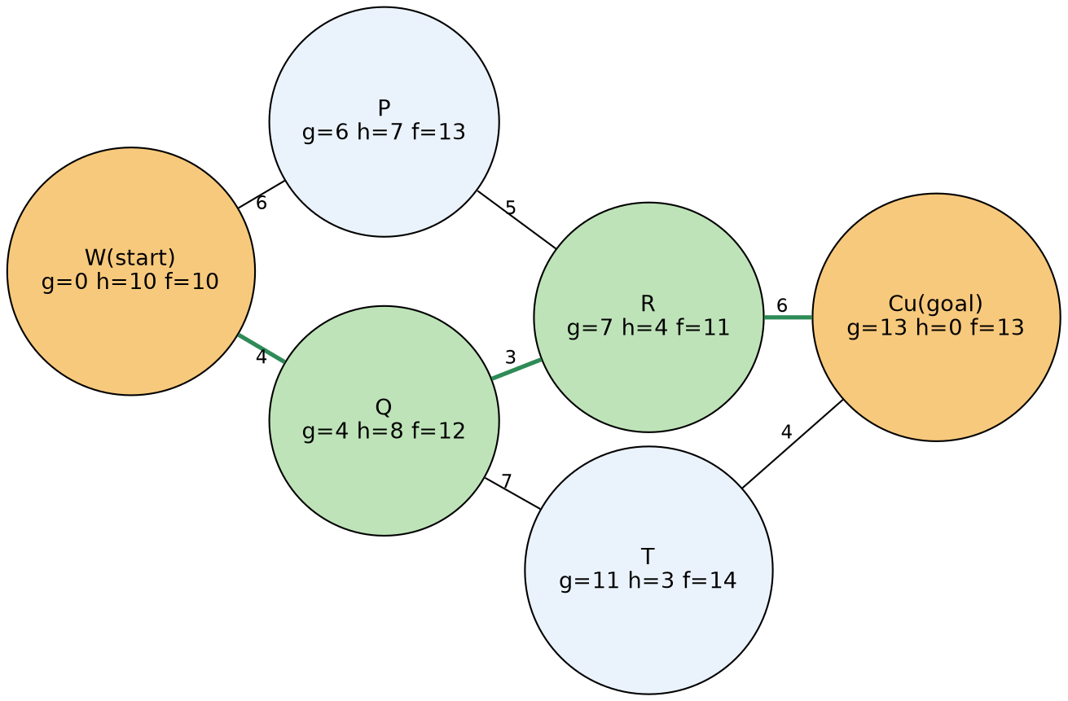

6. Variables, Domains, and Constraints (CSP)
Not Applicable — this is a path-search problem.

7. Heuristic Function
h(n) = estimated straight-line distance from n to Cu:
h(W)=10 h(P)=7 h(Q)=8
h(R)=4 h(T)=3 h(Cu)=0
Because h(n) never overestimates the true remaining road distance, it is admissible; it is also consistent across the edges used here (obeys the triangle inequality), so A* is guaranteed to find the optimal path without ever needing to re-open a closed node.

8. Algorithm Design / Pseudocode

A*-SEARCH(W, Cu):
g[W] <- 0 ; f[W] <- h(W)
frontier <- PriorityQueue ordered by f(n); insert W
while frontier is not empty:
n <- frontier.pop_min_f()
if n == Cu: return reconstruct_path(n)
for each neighbour m of n with edge cost c(n,m):
tentative_g <- g[n] + c(n,m)
if m unvisited OR tentative_g < g[m]:
g[m] <- tentative_g
f[m] <- g[m] + h(m)
came_from[m] <- n
insert/update m in frontier with priority f[m]
return FAILURE

9. Flowchart / Algorithm Diagram
Fig. 2 above also serves as the search diagram: the algorithm repeatedly expands the lowest-f node and relaxes its neighbours' g-values, following the green route to Cu.

10. Working / Execution Trace
Node Expanded | g(n) | h(n) | f(n) = g+h
W | 0 | 10 | 10
Q | 4 | 8 | 12
R | 7 | 4 | 11
Cu (goal) | 13 | 0 | 13

- Expand W (f=10): generates P (g=6,h=7,f=13) and Q (g=4,h=8,f=12).
- Expand Q (lowest f=12): generates R (g=7,h=4,f=11) and T (g=11,h=3,f=14).
- Expand R (lowest f=11): generates Cu (g=13,h=0,f=13).
- Cu now has the lowest f among P(13), T(14), Cu(13); since h is admissible, expanding Cu confirms the optimal cost.
Optimal path: W → Q → R → Cu, total cost = 4 + 3 + 6 = 13.

11. Complexity Analysis
Time complexity: O(b^d) in the worst case, but effectively O(b^(ε·d)) with a good heuristic (ε = heuristic error), far better than uninformed search in practice. Space complexity: O(b^d), since every generated node is retained for possible cost updates and path reconstruction — this is A*'s main practical drawback on large graphs.

12. Advantages and Limitations
- Advantages: complete and optimal given an admissible heuristic; more efficient than Uniform Cost Search due to heuristic guidance.
- Limitations: high memory consumption (stores all generated nodes); quality strongly depends on h(n) — a weak heuristic degrades toward Uniform Cost Search; not directly suited to very large or dynamically changing graphs.

13. Conclusion
A* computed the guaranteed-optimal route W→Q→R→Cu with total cost 13. This optimality guarantee — absent in GBFS — makes A* the preferred technique whenever true travel cost must be minimized. A possible improvement is a tighter, more informed heuristic (e.g. real road-network lower bounds) or switching to Weighted A*/D* Lite if road conditions change dynamically.

Question 3 — Constraint Satisfaction Problem (Exam Timetable)
Design an examination timetable without scheduling conflicting subjects at the same time as a CSP by identifying variables, domains, and constraints. Explain how MRV and Forward Checking improve efficiency.

1. Problem Statement
A university must schedule exams for several subjects into a limited number of time slots such that no two subjects sharing common students are scheduled in the same slot. This is modelled and solved as a Constraint Satisfaction Problem (CSP).

2. Problem Analysis
- Initial state: no subject assigned to any slot.
- Goal state: every subject assigned exactly one slot with no shared-student clash.
- Assumptions: the number of available slots is fixed and known (3 slots used here); the conflict information (which subjects share students) is known in advance.
- Constraints: a binary "not-equal" constraint between every pair of subjects sharing at least one student.

3. AI Technique Selection
Constraint Satisfaction Problem solved via Backtracking Search enhanced with the Minimum Remaining Values (MRV) heuristic and Forward Checking.

4. Justification of Algorithm
Exam scheduling assigns values (slots) to variables (subjects) under constraints — it has no path cost or heuristic distance to a goal, so path-search techniques such as GBFS, A*, or Minimax do not apply. CSP techniques are purpose-built for such assignment problems, and MRV with Forward Checking substantially reduce the search space by detecting dead ends (empty domains) immediately, compared to plain backtracking.
5. State Space / Constraint Graph Representation
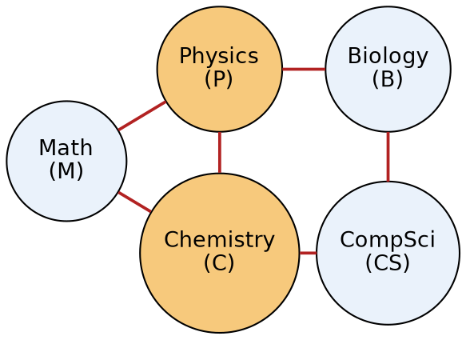
6. Variables, Domains, and Constraints
Variables: { M (Math), P (Physics), C (Chemistry), B (Biology), CS (Computer Science) }
Domains: each variable ∈ { S1, S2, S3 } (three available exam slots)
Constraints (all binary "≠"): M≠P, M≠C, P≠C, P≠B, C≠CS, B≠CS

7. Heuristic Function
Not Applicable in the search-cost sense; instead, variable/value-ordering heuristics are used — MRV selects the variable with the fewest legal values remaining, and the Degree Heuristic (tie-breaker) selects the variable involved in the most constraints with unassigned variables.

8. Algorithm Design / Pseudocode

BACKTRACKING-CSP(assignment, csp):
if assignment is complete: return assignment
var <- SELECT-UNASSIGNED-VARIABLE(csp) // MRV, tie-break: Degree Heuristic
for each value in ORDER-DOMAIN-VALUES(var, assignment, csp):
if value is consistent with assignment:
add {var = value} to assignment
inferences <- FORWARD-CHECKING(csp, var, value)
if inferences != failure:
result <- BACKTRACKING-CSP(assignment, csp)
if result != failure: return result
remove {var = value}; undo inferences
return failure

FORWARD-CHECKING(csp, var, value):
for each unassigned neighbour n of var:
remove value from domain(n)
if domain(n) becomes empty: return failure
return inferences

9. Flowchart / Algorithm Diagram
The constraint graph in Fig. 3 doubles as the assignment diagram: each assignment step removes the chosen value from all adjacent (constrained) subjects' domains, as traced below.

10. Working / Execution Trace
Step | Variable Chosen (MRV/Degree) | Assigned Value | Forward-Checking Effect
1 | P (degree 3, tie-break) | S1 | Removes S1 from M, C, B → M{S2,S3}, C{S2,S3}, B{S2,S3}
2 | C (degree 3, tie-break among size-2 vars) | S2 | Removes S2 from M, CS → M{S3}, CS{S1,S3}
3 | M (MRV: only 1 value left) | S3 | Consistent with P=S1, C=S2
4 | B (size-2 tie with CS) | S2 | No new removal (S2 already absent from CS)
5 | CS (last variable) | S1 | Consistent with C=S2, B=S2

Final timetable: P=S1, C=S2, M=S3, B=S2, CS=S1 — every constraint is satisfied and the solution was found with zero backtracking, demonstrating the pruning power of MRV + Forward Checking.

11. Complexity Analysis
Plain backtracking is O(d^n) in the worst case (d = domain size, n = number of variables) — here O(3^5) = 243 possible assignments. MRV and Forward Checking prune this drastically by detecting failure early and always branching on the most constrained variable first; in this instance they reduced the process to a single consistent assignment path with no backtracking. Space complexity is O(n·d) for domain storage plus O(n) for the recursion stack.

12. Advantages and Limitations
- Advantages: guarantees a valid, conflict-free timetable if one exists (complete algorithm); MRV+FC greatly reduce wasted exploration; easily extended with more slots, rooms, or invigilator constraints.
- Limitations: still exponential in the worst case for densely constrained or larger problems; Forward Checking does not detect all future failures (unlike full arc-consistency via AC-3), so some backtracking may still be needed for harder instances.

13. Conclusion
Modelling exam scheduling as a CSP with MRV and Forward Checking produced a conflict-free timetable efficiently and without backtracking. For larger, more heavily constrained timetabling problems, enforcing full arc-consistency (AC-3) alongside search, or using local search methods such as Min-Conflicts, would further improve scalability.

Question 4 — Minimax and Alpha-Beta Pruning
Design the Minimax algorithm for the given game tree to determine the best move for MAX. Apply Alpha-Beta Pruning to the same tree, indicate pruned nodes, and compare nodes evaluated before/after pruning.

1. Problem Statement
For a given two-player, zero-sum game tree, determine the best move for the MAX player using the Minimax algorithm, then apply Alpha-Beta Pruning to the same tree and compare the number of nodes evaluated before and after pruning.

2. Problem Analysis
- Initial state: root node representing the current game position, MAX to move.
- Goal state: identify the move (child of root) most favourable to MAX assuming MIN plays optimally.
- Assumptions: the game is deterministic, zero-sum, of perfect information; both players play optimally; terminal utility values are known.
- Constraints: search depth is limited to the given tree (depth 3, branching factor 2, 8 terminal leaves).

3. AI Technique Selection
Minimax algorithm, optimized with Alpha-Beta Pruning.

4. Justification of Algorithm
Minimax is the standard technique for adversarial, turn-based games, where an opponent actively counters the agent's moves — unlike single-agent search (GBFS/A*) or static assignment (CSP), it must account for optimal counter-play at every ply. Alpha-Beta Pruning is added because it provably returns the identical result as plain Minimax while skipping branches that cannot affect the final decision, making the search considerably more efficient with no loss of correctness.
5. State Space / Game Tree Representation
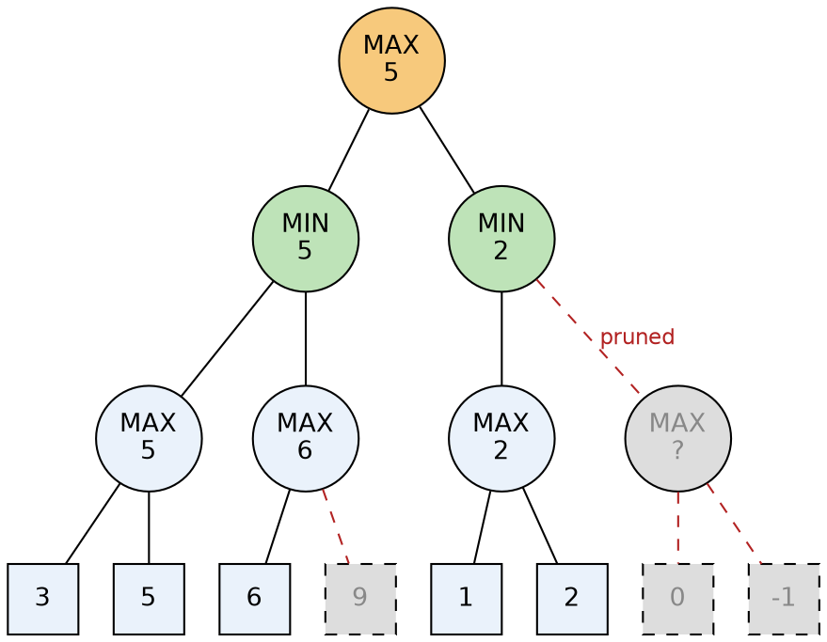
6. Variables, Domains, and Constraints (CSP)
Not Applicable.

7. Heuristic Function
Not Applicable — this is a fully-expanded finite game tree evaluated with exact terminal utilities rather than a heuristic static-evaluation function; in a larger game, a heuristic evaluation function would replace exact utility at a depth cut-off.

8. Algorithm Design / Pseudocode

MINIMAX(node, isMaxTurn):
if node is terminal: return utility(node)
if isMaxTurn:
v <- -infinity
for each child c of node: v <- max(v, MINIMAX(c, False))
return v
else:
v <- +infinity
for each child c of node: v <- min(v, MINIMAX(c, True))
return v

ALPHA-BETA(node, alpha, beta, isMaxTurn):
if node is terminal: return utility(node)
if isMaxTurn:
v <- -infinity
for each child c of node:
v <- max(v, ALPHA-BETA(c, alpha, beta, False))
alpha <- max(alpha, v)
if alpha >= beta: break // beta cut-off
return v
else:
v <- +infinity
for each child c of node:
v <- min(v, ALPHA-BETA(c, alpha, beta, True))
beta <- min(beta, v)
if alpha >= beta: break // alpha cut-off
return v

9. Flowchart / Algorithm Diagram
Fig. 4 above shows the full game tree together with the pruned branches, serving as the algorithm diagram.

10. Working / Execution Trace
Plain Minimax (bottom-up):
D = max(3,5) = 5 E = max(6,9) = 9 B = min(D,E) = min(5,9) = 5
F = max(1,2) = 2 G = max(0,-1) = 0 C = min(F,G) = min(2,0) = 0
Root = max(B,C) = max(5,0) = 5 --> Best move for MAX: subtree B
Alpha-Beta trace:
- Explore B branch: D returns 5, so B's beta becomes 5.
- Explore E: first leaf value 6 makes E ≥ 6; since 6 ≥ B's beta (5), a cutoff occurs — leaf 9 is pruned (never evaluated). E returns 6; B = min(5,6) = 5.
- Root's alpha updates to 5.
- Explore C branch with alpha = 5: F evaluates leaves 1 and 2, returning 2. C's beta becomes 2. Since beta (2) ≤ alpha (5), a cutoff occurs — the entire G subtree (leaves 0 and −1) is pruned, never evaluated. C returns 2.
- Root = max(5,2) = 5 — identical to plain Minimax; best move = subtree B.
Metric | Plain Minimax | Alpha-Beta Pruning
Leaves evaluated | 8 (all leaves) | 5 (3, 5, 6, 1, 2)
Leaves pruned | 0 | 3 (9, 0, −1)
Final game value / best move | 5 / subtree B | 5 / subtree B (identical)

11. Complexity Analysis
Plain Minimax: time O(b^d) (b=2, d=3 → 8 leaf evaluations); space O(b·d) for depth-first recursion. Alpha-Beta with good move ordering can reduce time complexity to O(b^(d/2)) in the best case — effectively doubling the searchable depth for the same cost; here it cut leaf evaluations from 8 to 5 (a 37.5% reduction).

12. Advantages and Limitations
- Advantages: Alpha-Beta always returns exactly the same decision as Minimax while doing strictly less (or equal) work; benefit increases greatly with good move ordering (evaluating the best move first at each node).
- Limitations: both assume a fully known, deterministic game with an optimal opponent — not applicable to stochastic or hidden-information games (which need Expectimax or extensions); for large games, exact leaf evaluation is infeasible, requiring depth-limited search with heuristic evaluation functions.

13. Conclusion
Minimax determined that MAX's best move leads to subtree B with game value 5. Alpha-Beta Pruning reached the identical decision while skipping 3 of 8 leaf evaluations, demonstrating its efficiency benefit without any loss of correctness. For larger trees (e.g. chess), move ordering, iterative deepening, and transposition tables would further amplify these savings.

Question 5 — Online Search Agent for a Dynamic Environment
A warehouse robot operates where obstacles may appear unexpectedly. Design an intelligent search strategy using Local Search or an Online Search Agent, explain adaptation to changes, and compare with informed search.

1. Problem Statement
A warehouse robot must navigate from its current position to a target location, but obstacles can appear unexpectedly during operation. We design an intelligent search strategy — an Online Search Agent — that lets the robot adapt in real time.

2. Problem Analysis
- Initial state: robot at a starting grid cell, with only the immediate surroundings sensed at t=0.
- Goal state: robot reaches the target cell despite unforeseen obstacle changes.
- Assumptions: the environment is revealed only as the robot moves/senses locally (unknown/dynamic environment); the robot observes obstacles only in its immediate vicinity, not the full map in advance.
- Constraints: the robot must never plan assuming full prior knowledge; re-planning must be cheap enough to run in real time whenever a new obstacle is detected.

3. AI Technique Selection
An Online Search Agent using Learning Real-Time A* (LRTA*) — a local-search-based, real-time adaptation of A* for unknown/dynamic environments.

4. Justification of Algorithm
Classical offline algorithms such as A* or GBFS require the entire state space to be known before search begins invalid here since obstacles appear unexpectedly. LRTA* interleaves acting and planning: the agent moves to the best-looking neighbour based on its current heuristic estimates, observes the actual environment and updates its heuristic table whenever its expectation is proven wrong.
5. State Space Representation
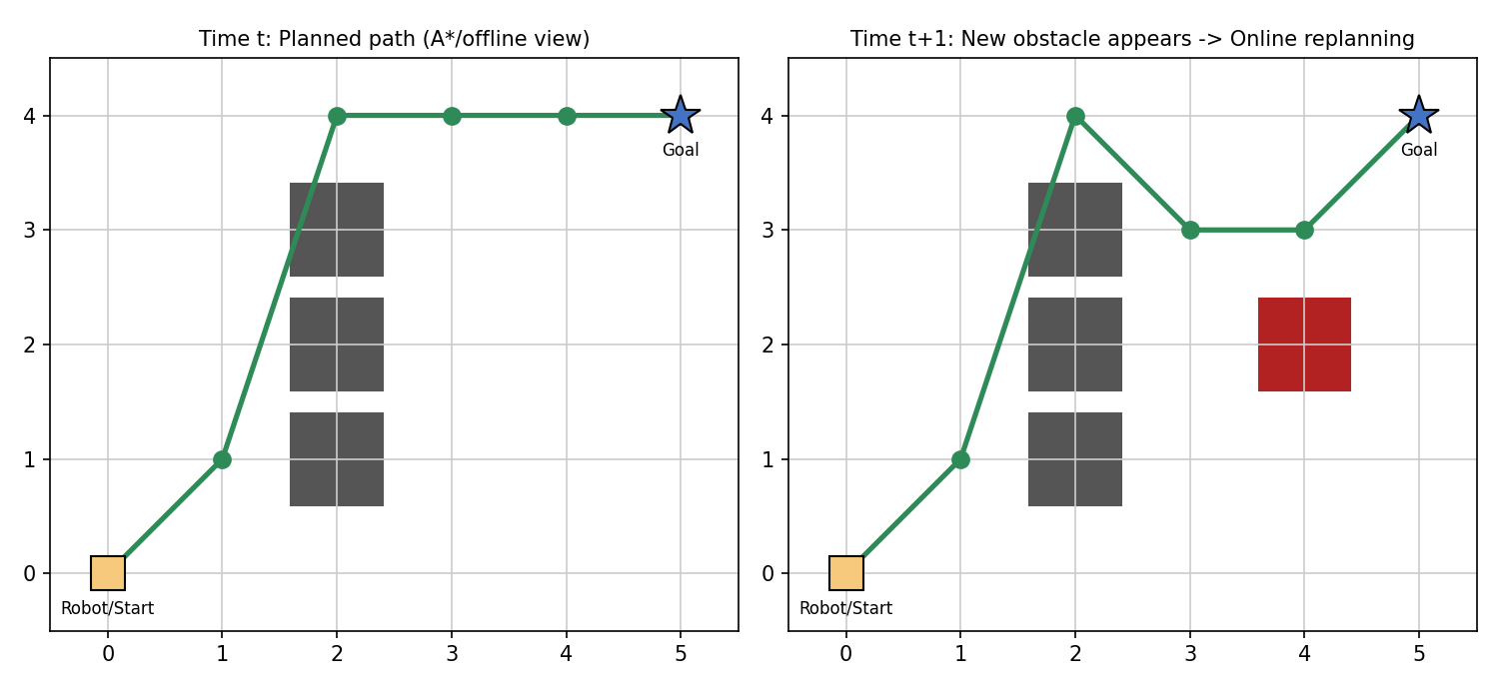

6. Variables, Domains, and Constraints (CSP)
Not Applicable.

7. Heuristic Function
h(n) = Manhattan distance from cell n to the goal, used as the initial estimate. LRTA* is "learning" because it updates h(n) online: whenever the robot discovers the true cost from n is higher than expected (e.g. a neighbour cell is found blocked), it revises
H(n) <- max( H(n), 1 + min over accessible neighbours m of [ cost(n,m) + H(m) ] )
so future decisions correctly reflect the newly learned obstacle information.

8. Algorithm Design / Pseudocode

LRTA*-AGENT(percept s'):
if GOAL-TEST(s'): return stop
if s' is a newly-seen state: H[s'] <- h(s') // initialise heuristic
if previous state s is not null:
result[s, a] <- s'
H[s] <- max( H[s], cost(s,a,s') + H[s'] ) // learn from experience
a' <- argmin over actions b applicable in s' of LRTA*-COST(s', b, result[s',b], H)
s <- s' ; a <- a'
return a'

LRTA*-COST(s, b, s', H):
if s' is unknown: return h(s)
else: return cost(s,b,s') + H[s']

9. Flowchart / Algorithm Diagram
Fig. 5 illustrates the loop: plan locally → move/sense → detect a change → update the H-table → re-plan the next step, repeated until the goal is reached.

10. Working / Execution Trace
At t=0 the robot senses the known obstacle column and follows its current best route: Start → (1,1) → (2,4) → (3,4) → (4,4) → Goal(5,4), based on Manhattan-distance estimates (left panel, Fig. 5).
While moving, the robot's local sensors detect a new, previously unknown obstacle directly ahead on the planned route. It immediately raises H for that blocked cell, propagates the update backward to the cell before it (whose best neighbour is now blocked), and recomputes only the next step locally — rather than restarting a global search — yielding the adapted route Start → (1,1) → (2,4) → (3,3) → (4,3) → Goal(5,4) (right panel, Fig. 5).
This demonstrates the key online-search behaviour: act → sense → detect discrepancy → update H-table → choose next action, repeated until the goal is reached.

11. Complexity Analysis
Per-step time complexity is O(b), where b is the number of accessible neighbours of the current cell, since the agent evaluates only its immediate neighbours rather than the entire graph. Space complexity is O(|S|) in the worst case, to store the learned heuristic table H over visited states only (it grows as new states are explored, not upfront). A single run can be less efficient than offline A* since LRTA* may revisit cells while learning, but it uniquely handles environments where offline complexity is undefined because the map is not known in advance.

12. Advantages and Limitations
- Advantages: operates without prior full knowledge of the environment; continuously adapts to dynamic obstacles; low memory/computation per step, suitable for real-time robotics; over repeated runs (e.g. repeated deliveries in the same warehouse) it converges toward optimal paths as H is learned.
- Limitations: individual runs can be inefficient or non-optimal (may revisit states while learning); performance depends on a good initial heuristic and frequent, reliable sensing; not guaranteed to find the shortest path on the very first attempt, unlike offline A* on a fully known static map.

13. Conclusion
An Online Search Agent using LRTA* lets the warehouse robot reach its goal despite unexpected obstacles, by interleaving movement with local heuristic learning instead of relying on a complete pre-known map. Compared to informed offline search (A*/GBFS), it trades single-run optimality for adaptability and real-time responsiveness. A hybrid approach — periodic A* re-planning combined with LRTA*-style local reaction to sudden obstacles — could combine the strengths of both in future improvements.

EVALUATION RUBRICS

Criteria | Weightage (%) | Excellent (90–100%) | Good (75–89%) | Average (60–74%) | Poor (<60%)
Problem Analysis and Understanding | 15% | 13–15% – Clearly identifies the problem, initial state, goal state, constraints, and expected outcome. | 10–12% – Identifies most problem components with minor omissions. | 7–9% – Demonstrates partial understanding with some missing elements. | 0–6% – Incorrect or incomplete understanding of the problem.
AI Algorithm Selection & Justification | 15% | 13–15% – Selects the most appropriate AI algorithm/search technique with strong technical justification. | 10–12% – Selects an appropriate algorithm with adequate justification. | 7–9% – Selects a partially suitable algorithm with limited justification. | 0–6% – Incorrect algorithm selection or no justification.
Algorithm Design / Pseudocode | 25% | 22–25% – Designs a complete, logical, efficient, and error-free algorithm/pseudocode. | 17–21% – Algorithm is mostly correct with minor logical errors. | 12–16% – Algorithm is partially complete with several logical errors. | 0–11% – Algorithm is incomplete, incorrect, or difficult to understand.
Application of AI Concepts (Greedy, A*, CSP, Minimax, Alpha-Beta, etc.) | 15% | 13–15% – Correctly applies the relevant AI concepts and techniques throughout the solution. | 10–12% – Applies AI concepts correctly with minor mistakes. | 7–9% – Demonstrates limited application of AI concepts. | 0–6% – Unable to apply the appropriate AI concepts or techniques.
Diagram / State Space / Search Tree Representation | 10% | 9–10% – Accurate, complete, and well-labelled diagram supporting the solution. | 7–8% – Diagram is mostly correct with minor omissions. | 5–6% – Diagram is partially complete or lacks clarity. | 0–4% – Diagram is missing or incorrect.
Complexity Analysis and Solution Efficiency | 10% | 9–10% – Correctly analyzes time and space complexity and proposes an efficient solution. | 7–8% – Complexity analysis is mostly correct with minor errors. | 5–6% – Partial complexity analysis or limited discussion of efficiency. | 0–4% – No meaningful complexity analysis or highly inefficient solution.
Originality, Critical Thinking, and Presentation | 10% | 9–10% – Demonstrates excellent originality, logical reasoning, organized presentation, and explores optimized/alternative solutions. | 7–8% – Demonstrates good critical thinking with a clear presentation. | 5–6% – Shows limited originality and acceptable presentation. | 0–4% – Poor presentation with little or no critical thinking.

